**עבודת סיום קורס מבוא לניהול נתונים :**

מגישות :

* רויטל עזורה ת.ז 032658767
* אהובה אבייב ת.ז 319395885

נושא העבודה סניפים הארץ של :

**דיאגרמה** 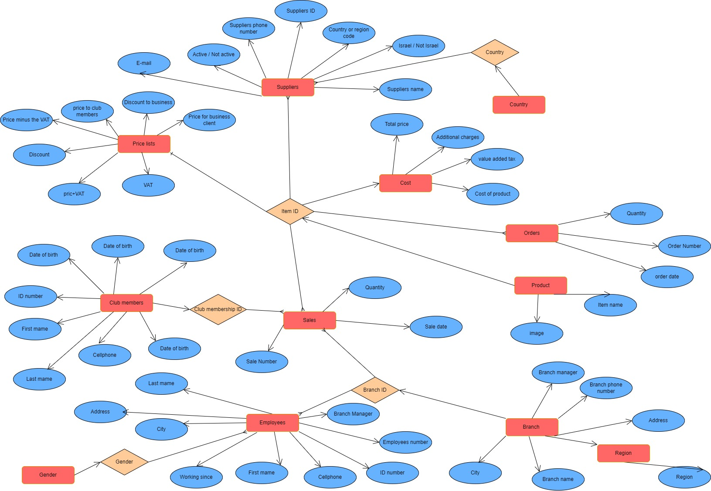:

|  |  |  |  |
| --- | --- | --- | --- |
| ## | השאילתא | קוד SQL | טבלאות/ שאילתות שנכנסו לשאילתא |
| 1 | מי הם הספקים הישראלים שפעילים | SELECT Suppliers.[Suppliers ID], Suppliers.[Suppliers name], Suppliers.Country, Suppliers.[Suppliers phone number], Suppliers.[E-mail], Orders.Quantity, Suppliers.[Active / Not active] FROM (Product INNER JOIN Orders ON Product.[Item ID] = Orders.[Item ID]) INNER JOIN Suppliers ON Product.[Item ID] = Suppliers.[Item ID] WHERE (((Suppliers.Country)="ישראל") AND ((Suppliers.[Active / Not active])=Yes)); | Suppliers, Orders, Product |
| 2 | וותק עובדים על פי סניף | SELECT Branches.[Branch name], employees.[First name], employees.[Last name], Avg(DateDiff("yyyy",[Working since],Date())) AS ותק FROM Branches INNER JOIN employees ON Branches.[Branch ID] = employees.[Branch ID] GROUP BY Branches.[Branch name], employees.[First name], employees.[Last name], employees.[Working since], Branches.[Branch ID] ORDER BY Branches.[Branch name], Avg(DateDiff("yyyy",[Working since],Date())); | Branches, employees |
| 3 | חברי מועדון לא בתוקף | SELECT Club_members.[Club membership ID], Club_members.[First name], Club_members.[Last name], Club_members.[E-mail], Club_members.[Expiration date], Date()<[Expiration date] AS [לא בתוקף] FROM Club_members WHERE (((Date()<[Expiration date])=0)); | Club_members |
| 4 | חיפוש לפי שם מוצר מלא | SELECT Product.[Item ID], Product.[Item name], Branches.[Branch name], Branches.[Branch phone number], Price­_lists.[pric+VAT], מלאי.[כמות במלאי] FROM (Price­_lists INNER JOIN Product ON Price­_lists.[Item ID] = Product.[Item ID]) INNER JOIN (Branches INNER JOIN מלאי ON Branches.[Branch ID] = מלאי.[Branch ID]) ON Product.[Item ID] = מלאי.[Item ID] WHERE (((Product.[Item name])=[הכנס שם מוצר מלא:])) ORDER BY Branches.[Branch name]; | Product, Price­_lists, מלאי, Branches |
| 5 | כמה נקנו מוצרים שעולים יותר מ- 100 ₪ או מתחת ל- 50 ₪ | SELECT Price­_lists.[Item ID], Product.[Item name], Sales.Quantity, Price­_lists.[pric+VAT] FROM (Price­_lists INNER JOIN Product ON Price­_lists.[Item ID] = Product.[Item ID]) INNER JOIN Sales ON Product.[Item ID] = Sales.[Item ID] WHERE (((Price­_lists.[pric+VAT])>150 Or (Price­_lists.[pric+VAT])<50)) ORDER BY Price­_lists.[Item ID] DESC; | Price­_lists, Product, Sales |
| 6 | מגדר העובדים : נשים /גברים | SELECT employees.Gender, Count(employees.Gender) AS CountמתוךGenderFROM employeesGROUP BY employees.Gender; | employees |
| 7 | מלאי מוצרים בחנויות | SELECT Sales.[Item ID], Product.[Item name], Sales.[Branch ID], Branches.[Branch name], Branches.City, Branches.Address, Branches.[Branch phone number], Sales.Quantity, Orders.Quantity, [Orders]![Quantity]-[Sales]![Quantity] AS [כמות במלאי] FROM Product INNER JOIN ((Orders INNER JOIN Sales ON Orders.[Item ID] = Sales.[Item ID]) INNER JOIN Branches ON Sales.[Branch ID] = Branches.[Branch ID]) ON (Product.[Item ID] = Sales.[Item ID]) AND (Product.[Item ID] = Orders.[Item ID]); | Sales, Product, Branches, Orders |
| 8 | מנהלי הסניפים | SELECT [First name] & " " & [Last name] AS מנהלים, Branches.[Branch name], employees.[Branch Manager] FROM Branches INNER JOIN employees ON Branches.[Branch ID] = employees.[Branch ID] WHERE (((employees.[Branch Manager])=Yes)); | Branches, employees |
| 9 | מספר עובדים בכל סניף | SELECT employees.[Branch ID], Branches.[Branch name], Count(employees.[Employee number]) AS [CountמתוךEmployee number] FROM Branches INNER JOIN employees ON Branches.[Branch ID] = employees.[Branch ID] GROUP BY employees.[Branch ID], Branches.[Branch name] ORDER BY employees.[Branch ID] DESC; | Branches, employees |
| 10 | רווח --בכל סניף , שמחולק לפי אזורים | SELECT cost.[Item ID], Product.[Item name], Price­_lists.[pric+VAT], cost.[Total price], [pric+VAT]-[Total price] AS רווח, Sales.Quantity, Sum([רווח]*[Quantity]) AS [סך הכל רווח], Branches.Region FROM Branches INNER JOIN ((Price­_lists INNER JOIN (cost INNER JOIN Product ON cost.[Item ID] = Product.[Item ID]) ON Price­_lists.[Item ID] = Product.[Item ID]) INNER JOIN Sales ON Product.[Item ID] = Sales.[Item ID]) ON Branches.[Branch ID] = Sales.[Branch ID] GROUP BY cost.[Item ID], Product.[Item name], Price­_lists.[pric+VAT], cost.[Total price], [pric+VAT]-[Total price], Sales.Quantity, Branches.Region; | cost, Product, Price­_lists, Sales, Branches |
| 11 | שמות הספקים לפי מדינות | SELECT Suppliers.[Suppliers ID], Suppliers.[Suppliers name], Suppliers.Country AS Suppliers_Country, Suppliers.[E-mail], Country.Country AS Country_Country FROM Country INNER JOIN Suppliers ON Country.[Country] = Suppliers.[Country] WHERE (((Country.Country)=[הכנס/י שם מדינת הספק])); | Suppliers, Country |
| 12 | שם מלא לחברי מועדון | SELECT Club_members.[Club membership ID], [First name] & " " & [Last name] AS [שם מלא] FROM Club_members INNER JOIN Sales ON Club_members.[Club membership ID] = Sales.[Club membership ID]; | Club_members, Sales |